**Trigger Manager**

This document explains you how to register trigger in Zap Automation.

**Steps:**

**Step1:** Open Zap Automation Task Editor, and drag and drop any trigger action from activity panel,

Suppose I use **Schedule Task Trigger**, Drag and drop action and set properties.

* **TriggerFireTime –** Set time to fire the trigger on set time (Time must be in millisecond).
* **RepeatDays –** Select weekdays or weekend which day you want to perform trigger.
* **AskBeforeExecuting –** Set **True**, if user want to ask always before execution of trigger, otherwise default is **False**.
* **IsDisabled –** Set **True,** if user want to disabled the trigger, otherwise default is **False**.

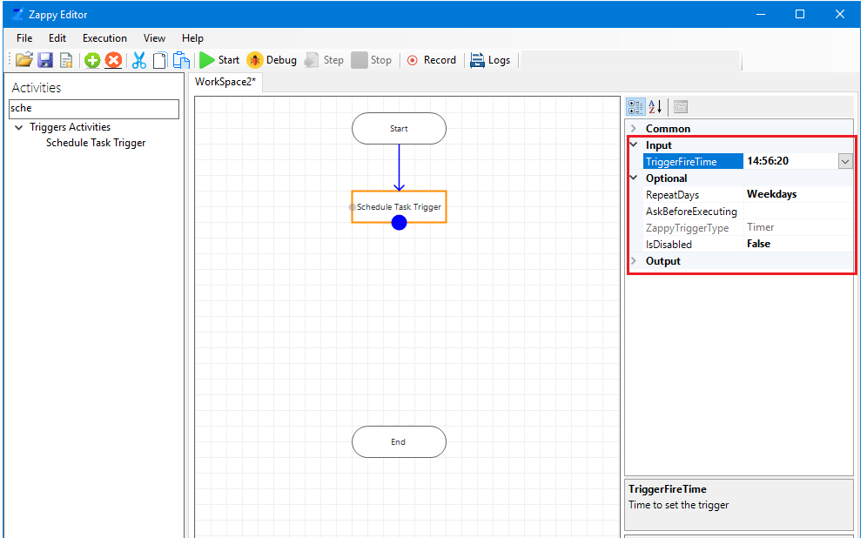

**Step2:** Save the automation by click on **Save**  button and to register the trigger click on **Start**  button.

**Step3:** After click on **Start**, you get message **“Successfully Registered Active Trigger”**

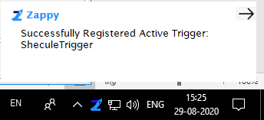

**Step4:** To open the Trigger Manager window, Right click on Zap icon from bottom right corner and select, **Tools -> Trigger Manager ->**

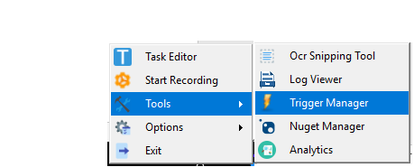

Trigger Manager form will pop up, this form contain list of the all registered triggers.

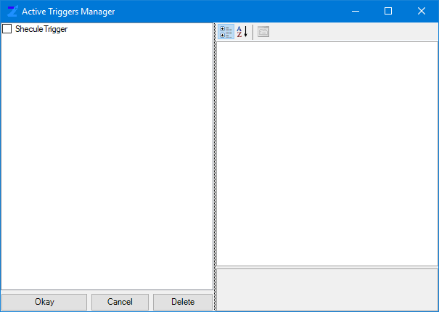

**Step5:** When user wants to do some changes on active registered trigger then select the particular trigger and change its properties.

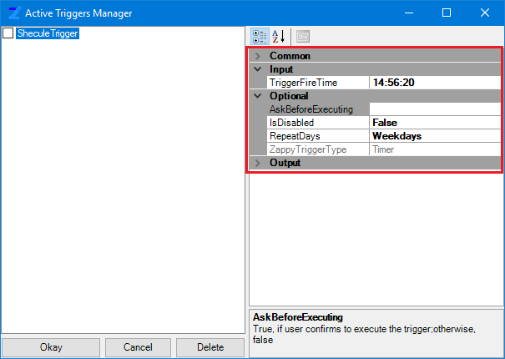

**Step6:** To Delete the registered trigger select specific trigger and click on **Delete** button,

user can disable registered trigger from Trigger Manager also to change property **IsDisable**, by changing property of set trigger.

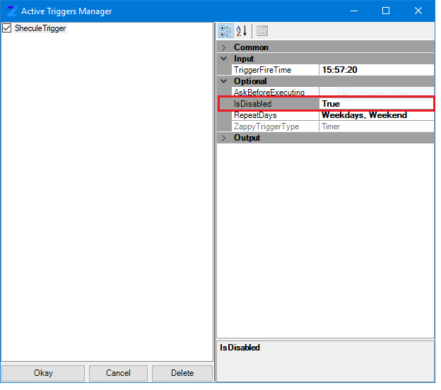

**Step7:** Trigger will be fired on set time and days period. You get message after successful fired the set trigger.

